Nambiar P, John J, Asif MK, Ibrahim N. Significance of an Unusual Notching on an Incisal Margin in a Bite Mark Investigation. Anil Aggrawal's Internet Journal of Forensic Medicine and Toxicology [serial online], 2020; Vol. 21, No. 2 (July - December 2020): [about 16 p]. Available from: http://anilaggrawal.com/ij/vol_021_no_002/papers/paper004.html. Published as Epub Ahead: Apr 12, 2020.

Access the journal at - http://anilaggrawal.com

************************************************************************
SIGNIFICANCE OF AN UNUSUAL NOTCHING ON AN INCISAL MARGIN IN A BITE MARK INVESTIGATION
Phrabhakaran Nambiar ^{a, c*}, Jacob John ^{b}, Muhammad Khan Asif ª, Norliza Ibrahim ª.
ª Department of Oral & Maxillofacial Clinical Sciences, Faculty of Dentistry, University of Malaya.
^{b} Department of Restorative Dentistry, Faculty of Dentistry, University of Malaya.
^{c} Department of Oral Biology and Biomedical Sciences, Faculty of Dentistry, MAHSA University, Bandar Saujana Putra, Malaysia.
Email address of each author:
Phrabhakaran Nambiar: phrabhakaran@mahsa.edu.my
Jacob John: drjacob@um.edu.my
Muhammad Khan Asif: dr.muhammad.khan@hotmail.com
Norliza Ibrahim: norlizaibrahim@um.edu.my
*Corresponding Author, Address and E-mail:
Prof. Dr. Phrabhakaran Nambiar
Department of Oral Biology and Biomedical Sciences,
Faculty of Dentistry, MAHSA University.
42610 Bandar Saujana Putra, Malaysia
Phone: +60 173620050.
Email: phrabhakaran@mahsa.edu.my

Significance of an Unusual Notching on an Incisal Margin in a Bite Mark Investigation

Abstract
A case of a suspected bite mark injury on the middle phalange of the right fourth (ring) finger was examined. This injury did not fulfill enough criteria as a typical human bite mark. Rectangular and two circular marks were noticed on its medial surface while the mark on the distal surface was indistinct. After performing the necessary investigative procedures, photography and impression taking, the individual characteristic details of the marks were compared with the biter’s maxillary central incisor teeth. Interestingly it was established that a notching on the incisal margin of the biter’s central incisor produced the distinctive marks that were consistent with the marks on the medial surface of the finger. Although a classic bite mark was not evident, the validity and reliability of this bite mark identification is certain because of the biter’s individual characteristics.
Keywords: Forensic odontology, Dentistry, Bite mark, Incisal margin.

Introduction
Bite marks can be found on various parts of the human body, although they are more common in certain accessible sites [1]. The rapid increase in skin bite mark cases has shifted the focus of research into this aspect of forensic dentistry. A case report in South Africa has demonstrated a positive relationship between the bite mark and the suspect's dentition. The expert concluded with a "high degree of certainty" that the bite mark present on the central abdomen of the victim was inflicted by the suspect [2]. The presence and recognition of bite or teeth marks in a living or deceased individual or in any other substrate is important to censure or eliminate a suspected offender. Teeth are remarkably versatile tools which on special occasions are weapons of attack or defense [3, 4]. However, there are challenges on the validity and reliability of bite mark and its admissibility in courts for a successful conviction. According to Pretty and Turnbull, bite mark analysis is based on two assumptions [5]. The first is that human teeth are unique, and the second is that sufficient detail of the uniqueness is rendered during the biting process to enable identification. With standardized protocols and best practice procedures, bite mark pattern investigation has an important contribution in the criminal justice system [6]. The science of bite mark investigation is challenging, and the need for the trained individuals and experience in the recognition, collection and analysis of this type of evidence is required and increasing [7].
Like fingerprint and DNA, bite mark pattern is unique to the maker of this type of injury. Bite marks may appear on any skin surface although with greater frequency on breasts, arms, legs and head [4, 8, 9]. There is increased frequency of females bitten over males, especially in the teenage years [10-12]. Reports have been made of forcible insertion of an arm into the victim’s mouth during a fight to subdue or stifle a cry by the victim [8, 13, 14]. The classic human bite mark in skin appears as a circular or oval ring-shaped or doughnut -shaped injury composed of two opposing arches facing one another and separated from each other at their bases [15, 16]. Each arch features an alignment of individual contusions, abrasions and /or lacerations that approximate the size, shape and arrangement of human teeth. The incisors record a row of broad rectangular marks while canines produce circular, triangular or diamond shaped marks determined by depth of penetration of the conical cusps [16, 17]. It must be remembered that bite mark is not always an imprint or impression but a reactive response generated by injured skin that is invariably less precise. A myriad of other unpredictable or irreproducible variables further confound the patterns displayed in bite marks. This includes skin thickness, elasticity, curvature, texture, vascularity, pigmentation, underlying support and direction and force during biting [3,8,16]. Additional variables include the age, gender and the health of the victim, including whether he/she is on any medication. It is therefore not uncommon in recent publications many researchers have challenged the concept of “uniqueness’ of human dentition. They pointed out to the fact that dental matches of multiple individuals are possible in the context of bite mark evidence [18]. Even the National Academy of Sciences (NAS) reported that the bite mark analysis is heavily criticized for its principles. One of the main reasons was the insufficient fundamental research that investigates the scientific basis of this method [19, 20]. However in this case report, it was possible to correlate bite skin injuries to the anterior teeth of a “biter’ when contemporary methods of investigations were performed.

Case report
This case illustrates that sometimes a bite mark injury does not fulfill enough criteria to merit distinction as a typical human bite mark. Marks on the right fourth finger (ring finger) of a cooperative “victim” introduced by the police were examined. Attention was specifically directed to the healing wounds on the middle phalange of the fourth finger. It was assumed that although the injury was a poor quality bite mark, a proper examination, recording and evaluation needed to be undertaken- until a possible comparison could be done to the suspect’s teeth to dismiss this case. Photographs were then properly taken with appropriate scale [13].
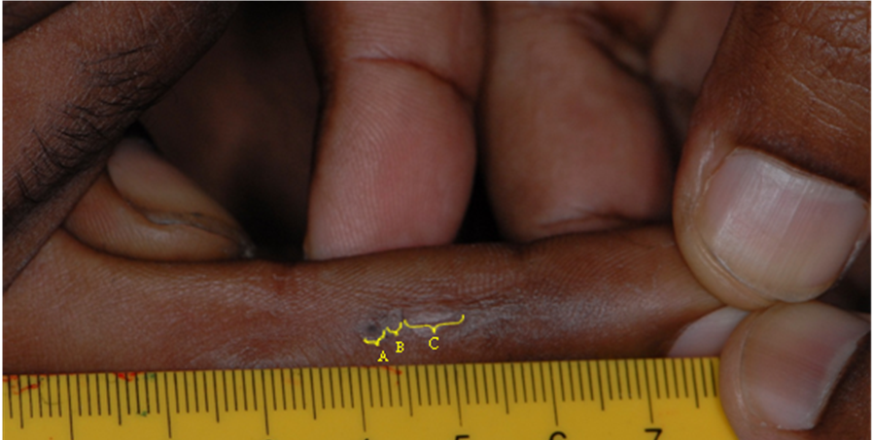

Figure 1: The healing mark on the medial surface of the right fourth finger of the “victim”.

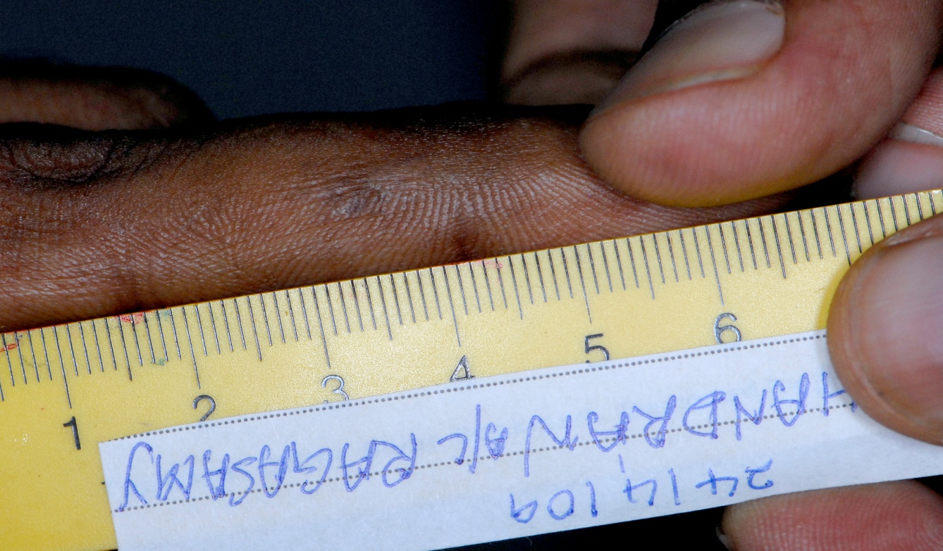

Figure 2: The indistinct mark on the distal surface of the right fourth finger of the “victim”.

The medial healing marks were somewhat a linear lesion and measured approximately 12 mm. There was a rectangular mark with two circular marks. The more superior circular mark showed a hyper pigmented site in the centre. On the other distal surface of the phalange, an area of post-inflammatory hyper pigmentation measuring approximately 5mm was observed. The mark was assumed to be of poor quality and the incisal teeth edge morphology appeared somewhat indistinct.
Subsequently, impressions of the two areas of the marks (on medial and distal surface) were taken using Impregum Penta Soft material - a polyether impression material (3M ESPE AG Dental Products, D 82229 Seefeld, Germany).
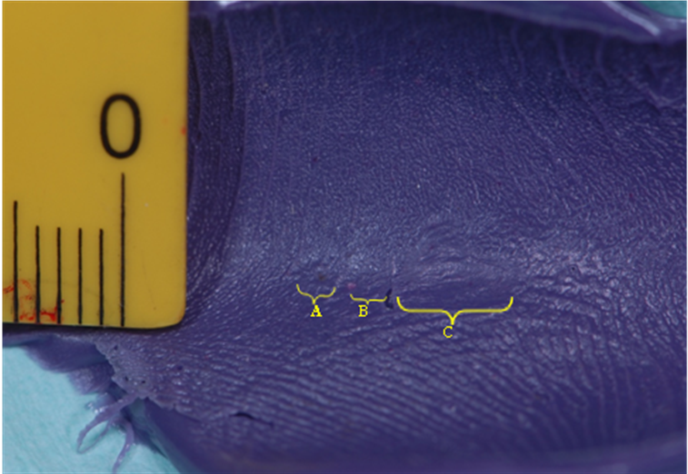
Figure 3: Impression of the bite mark on the medial surface of the right fourth finger of the “victim”.
Five days later the “offender” was introduced by the police for examination. Impressions of her teeth using Impregum Penta Soft and bite registration were recorded on dental wax. Study models were prepared from the impressions using dental stone.
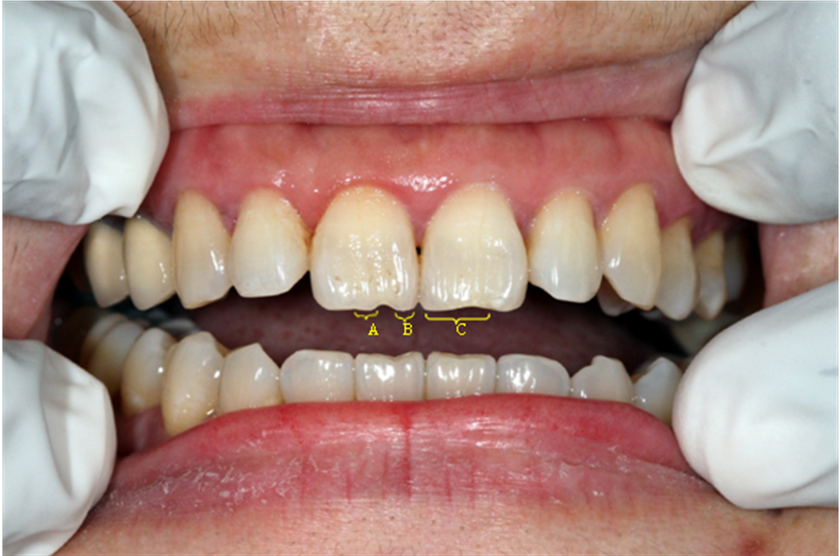

Figure 4: Photograph of the dentition of the “offender”.

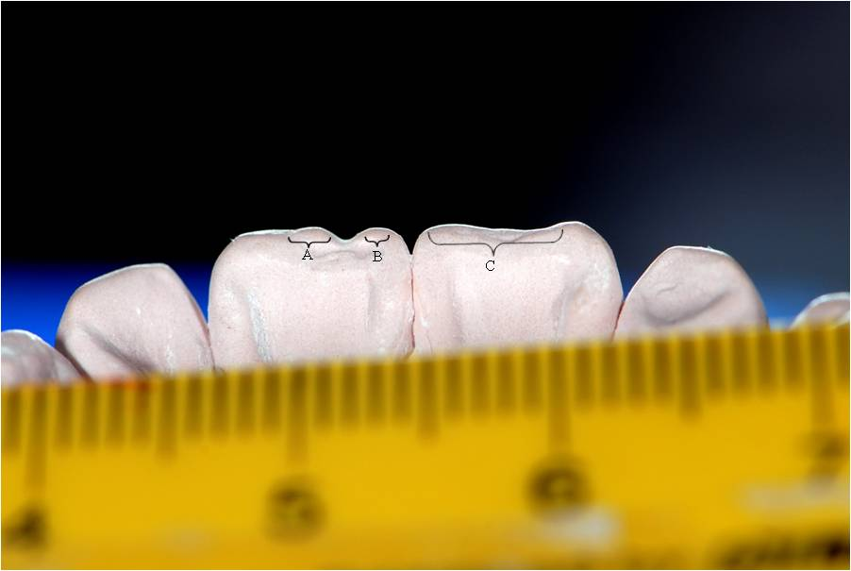

Figure 5: Photograph of the “offender’s” dentition from the palatal side of the maxillary study model.

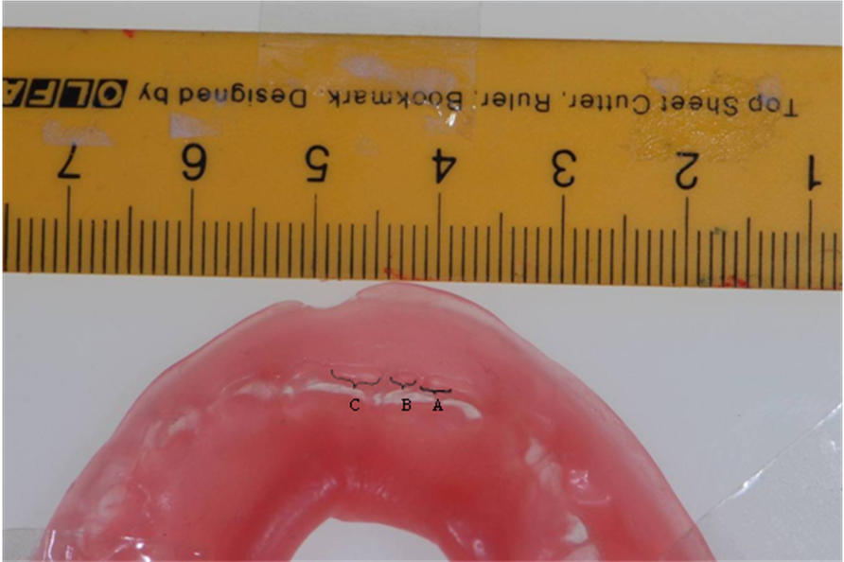

Figure 6: Indentations of the “offender’s” uppers incisor teeth recorded in dental wax.

Comparison of the pattern of the medial healing marks on the “victim’s” finger (from the photographs and impressions) with the central incisors of the maxillary study model of “offender” was undertaken. The healing deep abrasion and/or laceration on the medial surface of the right fourth finger were suggestive of human teeth marks. The characteristic pattern injury caused by the “offender’s” right and left upper central incisors was also revealed in the Impregum Penta Soft impression of the medial healing marks on the “victim’s” finger. The rectangular mark was produced by the left upper incisor tooth while the two distinctive circular marks were caused because of the presence of a notching on the mesial portion of the incisal edge of the right upper central incisor. The adjacent edges of this notching could have produced the two circular marks noticed.

The lesion on the distal surface of the finger was not sufficiently detailed or probably well healed to make any useful comparison with the "offender's" teeth. Therefore, it can be concluded that the deep abrasion and/or laceration marks on the medial surface of “victim’s” fourth finger (although of insufficient detail as it is healing satisfactorily) is consistent as having been produced by the upper central incisor teeth of the “offender”. The particular feature of a notching represents an unusual individual evidentiary characteristic and this indeed aided to identify the “offender” because the bite mark reproduced this distinctiveness.
The above police case-work had an interesting twist. The cooperative “victim” was actually a kidnapper who attempted to shut the mouth of the “offender” to prevent her from screaming. In the course of his action the “victim’s” finger was bitten and this depicted as an anger-impulsive biting [21]. Although the kidnapping of the “offender’s” son was initially successful, the police managed to apprehend the kidnappers, only after the ransom money was paid. This was the reason for the delay of two weeks in the examination of the bite mark which was healing satisfactorily.

Discussion
Bite mark analysis is greatly criticized due to lack of any rules, regulations, or processes to accredit experts or the testimony they provide in building standards. Furthermore, subjectivity, operators’ incompetence, or inadequate internal controls can affect the integrity of the results in an investigation. It is not surprising that Pretty and Sweet [22] used the term "highest level of forensic significance" which in effect does not imply "absolute certainty" in bite mark comparisons.
The injury here was classified as abrasion and/or laceration as there could have been actual break through the skin to deeper tissues [8,23]. In this injury, it was observed that there were areas of increased pigmentation in the marks. It is reported that any injury can heal with more, less or the same amount of melanin as the surrounding skin. Increased melanin is known as post inflammatory pigmentation while decreased melanin is also seen in some scars. Both these phenomena were more readily appreciated in this dark -pigmented “victim”. It is believed that these pigmentary changes may even maintain the pattern of the teeth mark for many months [16]. Paradoxically the pigmentary patterns can also be too subtle to be seen visibly (present as latent injuries) that can only be imaged by ultraviolet photography [3,24].
Bite marks can never be taken to reproduce accurately the dental conditions of the biter-i.e a mirror image cannot be expected. In addition, occasionally the individual characteristics of the teeth of the offender are absent in a bite mark [25]. Caution should be exercised in the analysis of bite mark evidence, given that the evidentiary uniqueness of human dentition is greatly diminished in the presence of high amounts of distortion [26]. The ability of the skin to register sufficient detail of biter’s teeth is highly variable and commonly achieves contradictory results [18]. This is probably due to the teeth of the biter being fractured, wobbly, did not reach the occlusal plane or was buffered by some clothing on the victim. However sometimes during qualitative analyses, peculiarities of the mark may be compared to a suspect’s dentition for the same characteristics [27]. Fortunately for the examiners of this case, the skin and subdermal tissues (where the bite mark was produced) were well supported by the bone in the finger and that accounted for the teeth to leave marks that were identifiable objectively. Furthermore luckily, we followed the necessary bite mark investigation procedures and were able to record unique features of this “not very convincing” bite mark. Eventually when the comparison was made, it was able to match with the individual characteristics of the “offender’s” teeth. Although the forensic identification of bite marks is undergoing paradigm shift to science-based proofs driven by DNA technology, this was not possible in this case due to extended lapse of time when investigation was instituted [28]. Fortunately, the anterior teeth uniqueness was transposed and recorded in the bite mark injury and the bite mark analysis was possible.

Conclusion
In conclusion, this case illustrates that a distinctive dentition is able to produce an equally distinctive bite mark with the retention of individualized tooth features, despite a healing period of nearly two weeks. This supports the observation of the 96% of ABFO diplomates who stated that the human dentition was both unique and accurately registered on human skin during the biting process [12].

Acknowledgements
We are grateful to the Ministry of Higher Education, Malaysia for providing the High Impact Research Grant No: UM.C/HIR/MOHE/Dent/19 to undertake research study on this case.

Conflict of interest

The authors have no relevant conflicts of interest to declare.

References
1. R. Lessig, V. Wenzel, Weber M. Bite mark analysis in forensic routine case work. Exp Clin Sci Int J. 2006;5:93-102.
2. Bernitz H, Owen JH, van Heerden WF, Solheim T. An integrated technique for the analysis of skin bite marks. J Forensic Sci. 2008;53:194-8.
3. Dailey JC, Bowers CM. Aging of bitemarks: a literature review. J Forensic Sci. 1997;42:792-5.
4. GL V. History in bite mark evidence. In: Dorion RBJ (ed) Bite mark evidence. 1st ed. New York: Marcel Dekker Publishers; 2005.
5. Pretty IA, Turnbull MD. Lack of dental uniqueness between two bite mark suspects. J Forensic Sci. 2001;46:1487-91.
6. Singh S. Teeth Don’t Lie: An evaluation of the admissibility and reliability of bitemark evidence in Malaysia. A research project submitted for fulfillment of the requirements for the degree of Master of Criminal Justice. Faculty of Law, University of Malaya, 2008.
7. Pretty IA. Forensic dentistry: 2. Bitemarks and bite injuries. Dental update. 2008;35:48-50, 3-4, 7-8 passim.
8. Pretty IA, Sweet D. Anatomical location of bitemarks and associated findings in 101 cases from the United States. J Forensic Sci. 2000;45:812-4.
9. W H. Dental identification and forensic odontology. 1st ed. London: Henry Kimpton Publishers; 1976.
10. Freeman AJ, Senn DR, Arendt DM. Seven hundred seventy eight bite marks: analysis by anatomic location, victim and biter demographics, type of crime, and legal disposition. J Forensic Sci. 2005;50:1436-43.
11. Vale GL, Noguchi TT. Anatomical distribution of human bite marks in a series of 67 cases. J Forensic Sci. 1983;28:61-9.
12. Rawson RD, Koot A, Martin C, Jackson J, Novosel S, Richardson A, et al. Incidence of bite marks in a selected juvenile population: a preliminary report. J Forensic Sci. 1984;29:254-9.
13. Luntz LL, P L. Handbook for dental identification: Techniques in forensic dentistry Philadelphia: J.B. Lippincott Company; 1973.
14. Whitakker DK, DG M. A colour atlas of forensic dentistry 1ed. Ipswich: Wolfe Medical Publications Ltd; 1989. p. 108-15.
15. Sweet D, Pretty IA. A look at forensic dentistry--Part 2: teeth as weapons of violence--identification of bitemark perpetrators. Br Dent J. 2001;190:415-8.
16. Berstein M L. Nature of bitemarks. In: Dorion RBJ (ed) Bite mark evidence. 1 ed. New York: Marcel Dekker Publishers; 2005. p. 59-80.
17. Levine L J. In: Cottone JA, Standish SM (eds) Outline of forensic dentistry 1ed. Chicago: Year Book Medical Publishers; 1982. p. 112-27.
18. Bowers C M. Recognition, documentation, evidence collection, and interpretation of bite mark evidence. In: forensic dental evidence-an investigator’s handbook. 2 ed. Boston: Elsevier Ltd.
19. Pretty IA, Sweet D. The scientific basis for human bitemark analyses--a critical review. Science & justice : journal of the Forensic Science Society. 2001;41:85-92.
20. Bowers C M. Legal issues concerning bitemark evidence in the United States. In: forensic dental evidence-an investigator’s handbook. 2 ed. Boston: Elsevier Ltd.
21. Webb DA, Sweet D, Hinman DL, Pretty IA. Forensic implications of biting behavior: a conceptually underdeveloped area of investigation. J Forensic Sci. 2002;47:103-6.
22. Pretty IA, Sweet DJ. The judicial view of bitemarks within the United States Criminal Justice System. J Forensic Odontostomatol. 2006;24:1-11.
23. Davis J H. Histology and timing of injury-invasive analyses. In: Dorion RBJ (ed) Bite mark evidence. 1 ed. New York: Marcel Dekker Publishers; 2005. p. 257-73.
24. Dinkel EH, Jr. The use of bite mark evidence as an investigative aid. J Forensic Sci. 1974;19:535-47.
25. Jakobsen JR, Keiser-Nielsen S. Bite mark lesions in human skin. Forensic Sci Int. 1981;18:41-55.
26. Lewis C, Marroquin LA. Effects of skin elasticity on bite mark distortion. Forensic Sci Int. 2015;257:293-6.
27. Dorion R B, J Bite mark evidence. J Can Dent Assoc. 1982;12:795-8.
28. Pretty IA, Sweet D. A paradigm shift in the analysis of bitemarks. Forensic Sci Int. 2010;201:38-44.

